First version

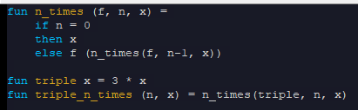

2nd version

* Triple as a local

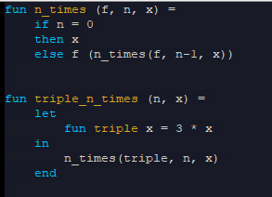

3rd version

* Directly passing triple as a local in the argument of n_times

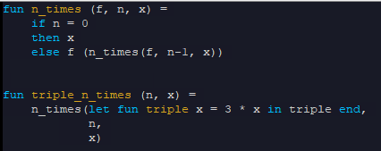

* Not really a good style

4th version

* Better construct than passing a let clause as an argument
* Anonymous functions

1st attempt:

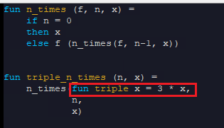

* But “fun” indicates a binding! Not an expression

2nd attempt:

* Replace “fun” with “fn”
  + These are for defining anonymous functions!
  + You cannot even give a name for this (hence the term anonymous)

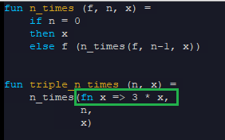

* fn (args) => (exp)

When to use anonymous functions

* Passing functions that you’re only gonna use in one place
* Functions that you are not calling on any other place in the code

